ACIDIC HYDROLYSIS OF WASTE FEATHER BIOMASS – PROCESS SCALE-UP
Hanika J.¹, Rousková M.¹, Šolcová O.¹, Šabata S.¹, Jírů M.², Hurková K.²
¹ Institute of Chemical Process Fundamentals Czech Academy of Sciences
² University of Chemistry and Technology, Faculty Food and Biochemical Technology
Abstract
The paper present novel data on acidic hydrolysis of waste chicken feathers in presence of water solution containing carboxylic acid catalyst with the pK_{a} value lower than 4, in stirred batch reactors, in the temperature range from 114°C to 150°C and at the pertinent vapour pressure of reaction mixture. The process was scaled-up from laboratory bench scale to pilot plant dimensions using batch high pressure autoclaves. Process conditions were applied according to patent application¹. Knowledge of kinetic aspects of the feather hydrolysis and process parameters operation window are inevitable for a successful process scale up^{2,3}.
Experiment
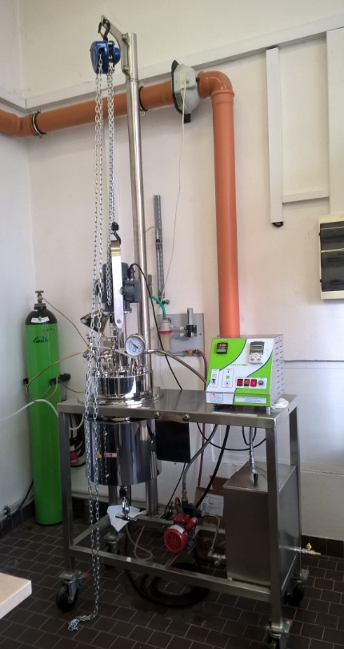
Low molecular proteins, amino-acids and free fat acids formation by parallel keratin and tri-acyl-glycerol hydrolysis were investigated under similar reaction conditions in our previous studies^{2,3}. Experiments were carried out using fried chicken feathers from Rabbit Co. Trhový Štěpánov. This waste material (typically 300 ml, weight 75 g and 1500g) together with 1 and 15 litters tap water and small amount of malic acid (up to 150 g) was put into pressure autoclaves, volume 2 and 25 litters, (see figure), respectively. The reaction product was separated by filtration to liquid hydrolysate (pH of the hydrolysate was about 5.5 in all cases) and solid waste which was dried to investigate a mass balance equilibrium of hydrolysis. The mass balance of the individual tests was nearly identical. The mass deficit was undoubtedly caused by handling losses as emptying the autoclave, separation of reaction products, filtration and drying of the solid waste. Liquid filtrate was analysed using HPLC/MS and GC/MS methods. The total content of soluble peptides of a low molecular weight and amino acids distribution were determined in the hydrolysate for all samples. Several samples were used for screening of feather fat hydrolysis products like free fatty acids, mono-, di- and tri-glycerides of different fatty acids as well. The experiments confirmed the statement: The waste chicken feathers represent the promise biological resources⁴.
Acknowledgement: Financial support from the Technology Agency of the Czech Republic, the Competence Centre BIORAF (project No. TE01020080) is gratefully acknowledged.
Literature
- Hanika J., Šolcová O., Hajšlová J., Zachariášová M., Jírů M., Kaštánek P., Bízková Z., Hrstka Z., Fulín T.: A method of preparing a mixture of proteins and amino acids with a predominant content of aspartic acid, CZ Pat. 306431 (2016), PV-2015-629.
- Hanika J., Kastanek P., Rouskova M., Sabata S., Solcova O.: Kinetics of keratin acidic hydrolysis in batch autoclave, Proc. 5th Int. Conf. Chem. Technol.,pp. 21-25, Mikulov, 10-12 April 2017.
- Rousková M., Šolcová O., Šabata S., Jírů M., Hůrková K., Hanika J.: Simultaneous hydrolysis of proteins and fats from waste chicken feathers, Proc. 6th Internat. Conf. Chem. Technol., Mikulov, April 16 - 18 (2018), pp. 51-55.
- https://doi.org/10.1016/j.wasman.2012.08.001
Fig.1: Pilot plant 25 litre autoclave, Nano-Mag Technologies Pvt. Ltd., Mumbai
(stainless; design temperature and pressure: 250 ºC; 100 bars)

